

<https://www.kizoa.fr/Video-Maker/d101539132k8732074o1>

34

_________________________________________________________________________________

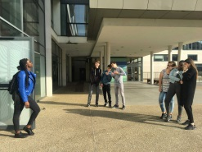

<https://www.kizoa.fr/Movie-Maker/d102477055k2249075o1/32>

32

____________________________________________________________________________



<https://www.kizoa.fr/Video-Maker/d101507602k1107525o1>

33

_____________________________________________________________________________

36

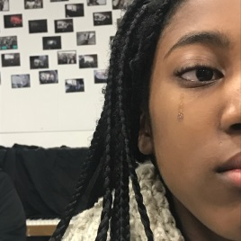

<https://www.kizoa.fr/Movie-Maker/d101498302k8201521o1/36>

_____________________________________________________________



37

<https://www.kizoa.fr/Video-Maker/d107554036k9790129o1>